Types of manuscripts: ____________________ (Types of manuscripts are listed in “Earozoru Kenkyu Information for Authors”)

Making Research Paper
－Template for “Earozoru Kenkyu”－

Taro EAROZORU^{1*}, Sakura BIRYUSHI²，Manabu KYOTO¹

¹ Japan Association of Aerosol Science and Technology
332-6 Yamabukicho, Shinjuku-ku, Tokyo 162-0801, Japan
- Faculty of Science and Technology, Aerosol University
Kakuma-machi 1, Kanazawa, Ishikawa 920-1192, Japan

* Corresponding Author.
E-mail: jaast-edit@bunken.co.jp (T. Earozoru)
Tel: 03-6824-9363
Abstract
The length of the abstract should be 100-200 words. In abstract, the subject of the paper, the methods, results, and discussion should be summarized concisely. ･････････････････････････････････････････････････････････････････････････････････････････････････････････････････････････････
（Abstract must be a summary of the object, methods, results and discussion of the paper. It should consist of 100 to 200 English words. An abstract is not necessarily required for general articles (foreword, proposal, á la carte, my way, new face, event report, aerosol square, etc.).

Keywords: Term1, Term2, Term3, Term4, …
（For key words, extract 5 to 10 important words that describe the essence of the paper and list them in English. Keywords are not required for general articles.

１．Introduction
This template file gives you a guide for preparing papers for “Earozoru kenkyu” journal. It is a summary of the preparation procedure for manuscripts based on the “Information for Authors”. Prepare legible and comprehensible manuscripts in an appropriate format in accordance with this template. If you would prefer to use the other word processing software, please follow the instructions in this document. Manuscripts should be prepared in either Japanese or English according to the “Information for Authors” (https://www.jaast.jp/kenkyu/new2/GuidelineE.pdf). Manuscripts that do not comply with these rules may not be accepted.
2. Text of a manuscript
2.1 Manuscript paper
For English manuscripts, print Times New Roman, 12 point and double-spaced on A4 or Letter size paper, leaving a liberal margin (2 cm) on all four sides. Approximately 800 words will correspond to 1page of final print. The manuscript, including figures and tables, is limited in length to the following number of printed pages for manuscripts in either Japanese or English.
Research paper: 6 pages Discussion 2 pages
Technical paper 6 pages Feature article 6 pages
Review paper 8 pages Interpretive paper 6 pages
Letter 2 pages New face 4 pages
Note 4 pages Aerosol square a half page
Foreword 1 page
My way, Á la carte, Proposal, Event report, etc. 2 pages
2.2 Format of manuscript
The manuscript of an original paper and a feature article should consist of i) abstract and keywords, ii) text, iii) nomenclature，ⅳ) references，v) tables，and ⅵ) figures.
2.3 Notation for figures, tables and equation numbers in the text
1) Fig.1, Fig.1, 2
2) Table 1, Tables 1, 2
3) Eq.(1), Eqs.(1), (2)
4) Figure and table numbers should be bold at the first time they appear.
2.4 Nomenclature
Use the International System of Units (SI) for units in the text. Quantity symbols, units, chemical symbols, and mathematical symbols should follow below the lists of the most important notation rules below.
- Quantity symbols should be italic e.g.: m(mass), ρ(density), p(pressure)
- Dimensionless parameters should be italic e.g.: Re, Pe, Kn, Fr
- Unit symbols should be Roman e.g.: N, Pa, N･m, J･kg⁻¹･K⁻¹
- Chemical symbols should be Roman e.g.: He, C, H₂O, Ca²⁺
- Numeric values should be Roman e.g.: 1, 2, 3
- Constants and operators of mathematical symbols should be roman in principal and variable symbols should be italic
e.g.: e, log, sin, exp should be roman. dx/dt, d should be roman,
x and t should be italic. f(x), both symbols should be italic.
- Vectors should be bold
- In the list of nomenclature, units should be enclosed in parentheses “( )”. Units following quantity symbols should be enclosed in parentheses. Units following values should not be enclosed in parentheses. e.g.: p(Pa), 55 Pa
2.5 Notation of mathematical formula
Equations should be placed on the head of the line and the number of equations should be enclosed in parentheses right-justified in the same line of equation. The font size of the mathematical equation editor follows that of the text in principle.
e.g.:
(1)
(2)
If necessary, summarize the used symbols and explain the nomenclature in English at the end of the manuscript. (Do not capitalize the words).
3. References
3.1 Listing order
List all references in English. The order of listing should be as follows
i）Name(s) of author(s) (List names of all authors, in principle. Use periods (“.”) for initials of author(s))
ii）Title of the paper or book (If the paper is not found in a book, type the editor’s name and add “ed.”)
iii）Title of the journal or publication office (when citing an English journal, abbreviate the title of the journal using periods in accordance with international usage. The title of the journal should be mentioned and “ibid.” should not be used. Abstracts and other than full references should be cited in principle.)
iv）Volume No.
v）Page No.
vi）Year of publication (Gregorian Calendar)
When citing submitted papers that have been notified of acceptance, add “(in press)”at the end. For Japanese references, type the Japanese title of the journal in romaji (English alphabet) and add “(in Japanese)” at the end. When the cited paper is a collection from conferences, symposiums, and so on, specify “Proceedings”, “Symposium”, etc. by showing Author(s), Title of paper, Name of meeting/conference, Page No., Year (in parentheses). For references in the form of electronic media, type the ISBN and title. Also online articles follow the same guidelines as printed articles. If an information source, such as a journal article, has been assigned a DOI (Digital Object Identifier), add the DOI at the end of the citation or in place of page numbers. Information on the World Wide Web is not approved as a reference, in principle, but if it is indispensable, show the website URLs of the Web sites and your date of access in parentheses in the text.
References can be listed either in the order of appearance in the text or in alphabetical order as described below.
3.2 Order of appearance in the text
Assign numbers in the order of appearance in the text. In the text, specify the citation with serial numbers using a single right closing parenthesis (e.g.:xxx¹⁾). When references are cited just to explain tables or figures, assign numbers in the order in which the table or figure appears in the text.
3.2.1 Example of reference format for the order of appearance in the text
References
- Iinoya, K.:“Syujin Kogaku”, 3rd ed., p.96, Nikkan Kogyo (1980) (in Japanese)
- Masuda, S.: Latest Progress in Electrostatic Precipitation, Earozoru Kenkyu, 1, 6-16 (1986) (in Japanese)
- Emi, H. and Otani, Y.: Removal of Fine Particles from Water by Pulse Air, J. Aerosol Sci., 16, 155 (1995)
- Furuuchi, M. and Kanaoka, C.: Influence of Geometry of Supersonic Virtual Impactor on Separation Performance of Ultra-Fine Particles, Proc. of 2006 Annual Meeting of the Institute of Electrostatics Japan, 171-172 (2006) (in Japanese)
- Okuyama, K.: Aerosol Nanoparticle Research in Material Science and Engineering, Proc. of 2006 Annual Meeting of the Institute of Electrostatics Japan, CD-ROM(ISDN-XXXX) (2006) (in Japanese)
- Murakami, M: What is Rainmaking, Earozoru Kenkyu, 30, 5-13 (2015) doi:10.11203/jar30.5 (in Japanese)
- Sadakata, M: Development of Dry Desulfurization Process Using Chain Reaction For Developing Countries, www.cdc.gov/nciod/EID/vol1no1/morse.htm (accessed 5 Jun 2015) (in Japanese)
3.3 Alphabetical order
References cited by the last name of author(s) (use et al. for three or more authors) and the year. (e.g.: (Emi, 2000); (Emi and Otani, 2000); (Emi et al., 2000)). If the author’s name is part of the sentence only the year is bracketed (e.g: Emi et al. (2000). When the author and year of publication are the same, add a, b, c after year of publication (e.g.: (Emi, 2000a), (Emi, 2000b)).
3.3.1 Example of reference format for the alphabetical order
References
Emi, H. and Otani, Y.: Removal of Fine Particles from Water by Pulse Air, J. Aerosol Sci., 16, 155 (1995)
Furuuchi, M. and Kanaoka, C.: Influence of Geometry of Supersonic Virtual Impactor on Separation Performance of Ultra-Fine Particles, Proc. of 2006 Annual Meeting of the Institute of Electrostatics Japan, 171-172 (2006) (in Japanese)
Iinoya, K.:“Syujin Kogaku”, 3rd ed., p.96, Nikkan Kogyo (1980) (in Japanese)
Masuda, S.: Latest Progress in Electrostatic Precipitation, Earozoru Kenkyu, 1, 6-16 (1986) (in Japanese)
Murakami, M: What is Rainmaking, Earozoru Kenkyu, 30, 5-13 (2015) doi:10.11203/jar30.5 (in Japanese)
Okuyama, K.: Aerosol Nanoparticle Research in Material Science and Engineering, Proc. of 2006 Annual Meeting of the Institute of Electrostatics Japan, CD-ROM (ISDN-XXXX) (2006) (in Japanese)
Sadakata, M: Development of Dry Desulfurization Process Using Chain Reaction For Developing Countries, www.cdc.gov/nciod/EID/vol1no1/morse.htm (accessed 5 Jun 2015) (in Japanese)

4. Tables and figures
All of tables and figures must be written in English in principle. The tables and figures within the illustrations or charts should be in accordance with the following rules.
- Tables should be typed on a separate page. Assign numbers in the order of citation in the text. Type the heading of the table above the table.
- Figures should be numbered in a series and cited in order in the text. Each figure should be drawn on a separate page. Type the title of the figure under the figure.
- Original figures submitted by the author will be published as they are. Therefore, prepare figures considering the width of the lines and the size of letters when figures are reduced to print size.
- Units of axes should appear in parentheses after the axis name, as required.
- Each figure should have a concise caption describing accurately what the figure depicts. Describe the captions in text on the same figure sheet but do not include titles or captions within your figure image.
- When preparing color figures, authors have to make reasonable efforts to consider “Color Vision Diversity*”.
*It is well known that there are more than 200 million people with minor specifications to recognize and classify colors (Color Vision Minority) which is the almost equivalent number of the people with AB-positive blood type. We can consider this issue as follows.
- Do not use many colors to differentiate the traces in the graph (i.e., use different line types, marker types, and fill types (open or filled), see Fig. 3 as an example).
- Consider color combinations (do not use the pairs of warm (cold) colors in a graph, and recommend to the use of high-visibility color maps such as “viridis”, etc., see Fig. 4 as an example).

To check the color visibility of the prepared figure, it is useful to try a simulator (https://www.color-blindness.com/coblis-color-blindness-simulator/).

Example of a table

Table 1 Example of a table.
T  (K) | c_{p}  (J･kg⁻¹･K⁻¹) | η  (Pa s)
 | ×10³ | ×10⁻⁵
300.0 | 1.007 | 1.962
310.0 | X.XXX | X.XXX
320.0 | X.XXX | X.XXX

Example of a figure

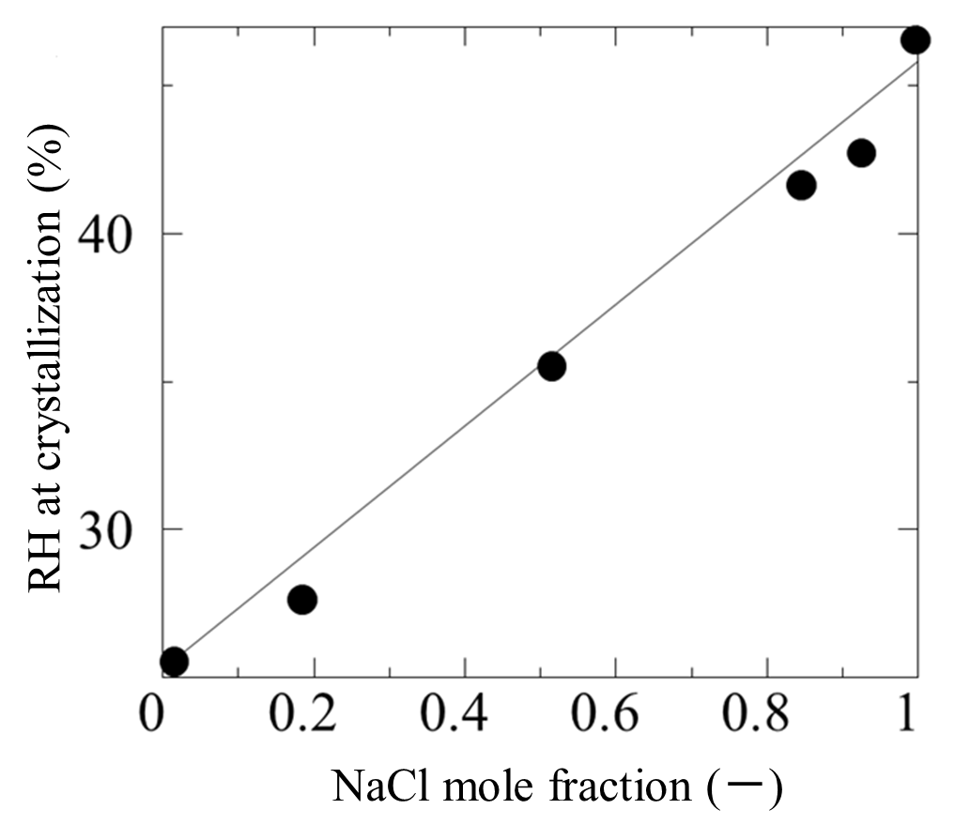
Fig. 1 Example of a figure. The solid circles (●) indicate the effects of the composition of the mixed particle of NaCl and NaBr on the RH at crystallization from a droplet.

(a)
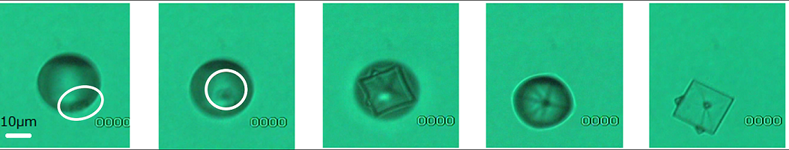
(b)
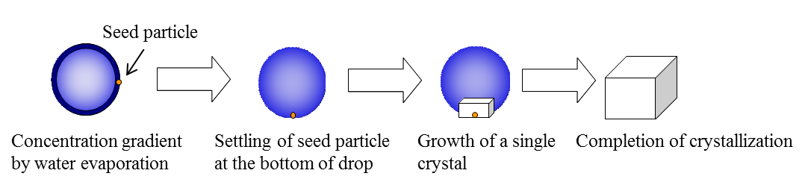

Fig.2 Example 2 of a figure (online version in color)．
(a) Photographs of crystallization, (b) Crystallization model

(a)
(b)

Fig.2 Example 2 of a figure (online version in color)．
(a) Photographs of crystallization, (b) Crystallization model

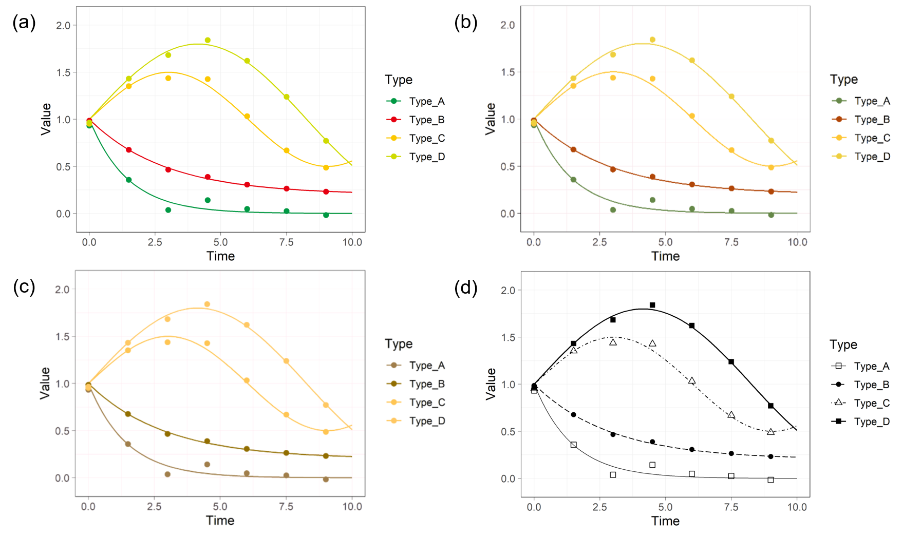
Fig. 3 Examples of the temporal variation in the scores for Types A–D, that seen with the human color-deficiencies, (a) normal color vision, (b) deuteranomaly and (c) deuteranopia, and (d) an example that modified by the black-and-white conversion and changing the line and marker types. It is hard to resolve Type-C and D in 3b and 3c, and Type-A and B in 3c. It is clearly found from 3d that reducing the number of colors used and changing the line and marker types are helpful in improving the visibility of the figure.

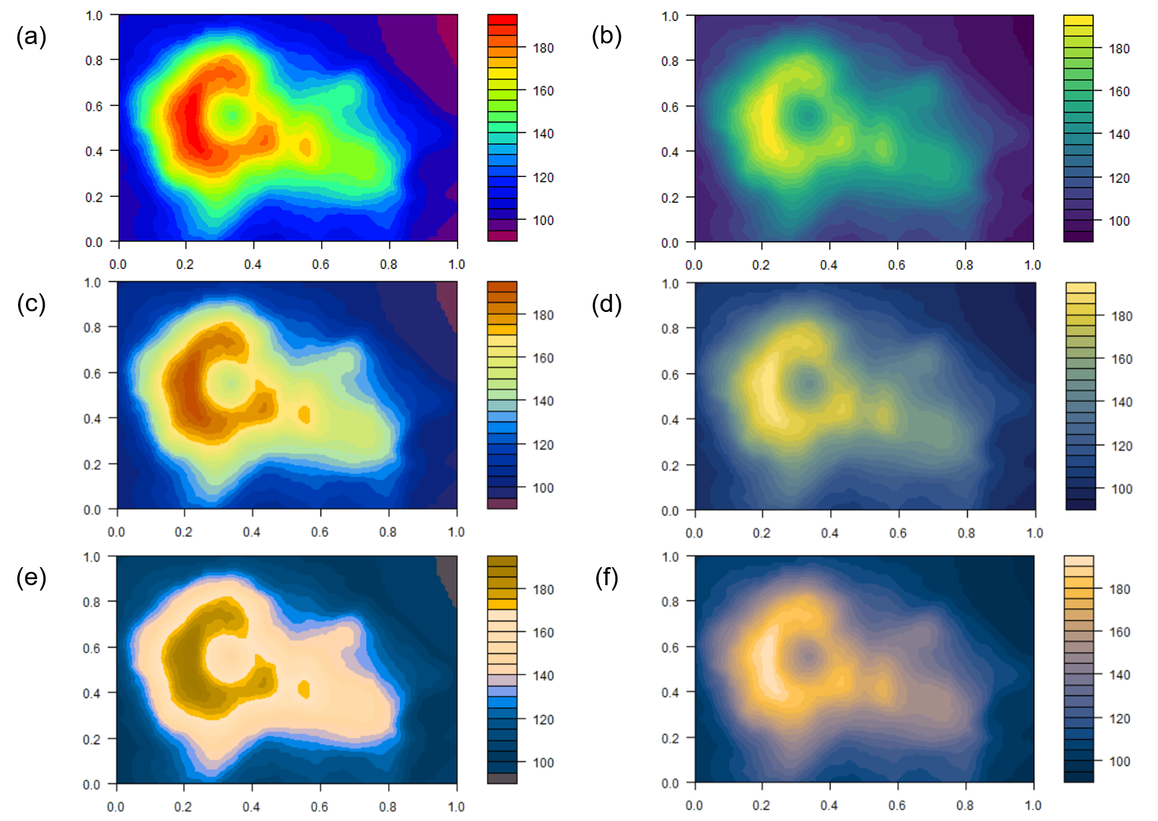
Fig. 4 Example images colored by different colormaps (a) rainbow and (b) viridis and those seen with the two types of human color-deficiencies, deuteranomaly (c; rainbow and d; viridis) and deuteranopia (e; rainbow and f; viridis). Rainbow, the most-widely used colormap, fails to reproduce a meaningful smooth gradient with the selected color deficiencies, yet viridis colormap is clearly readable.

